**Classic BADI with FILTER**

1. Go to tcode SE18.Give a BADI name starting with Z/X. Go to Utilities->Create Classic BADI.

(Do not click create)

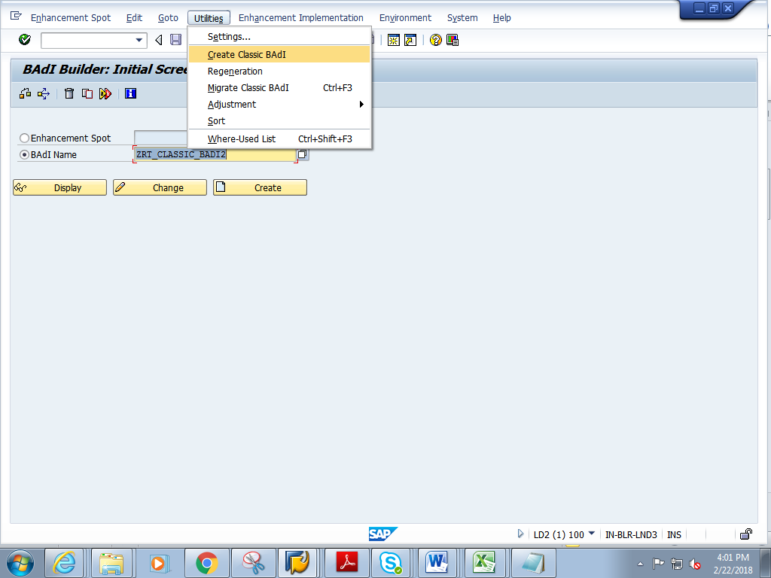

1. Give a short description. **Check the Filter Depend**. **In the Filter type, give the Data Element name Eg. S_CARR_ID .**  
   Click on the interface tab.

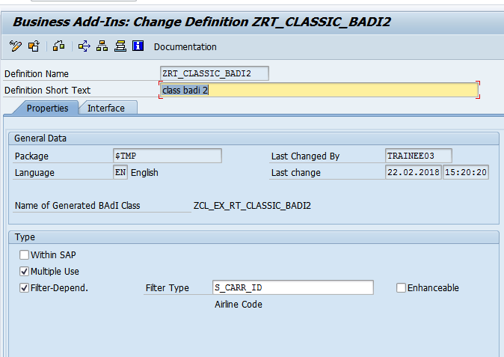

1. In the interface, add the method METH_FLIGHT as shown below. Click on Parameters

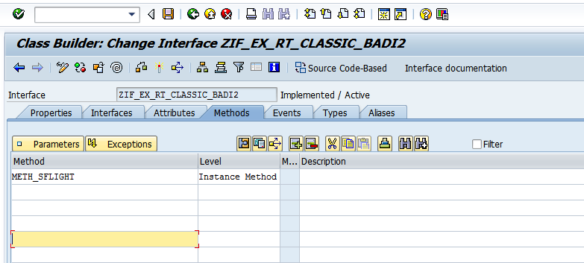

1. Give 2 parameters I_CARRID and E_SFLIGHT

(Note: ZBADI_SFLI is a table type of line type SFLIGHT)

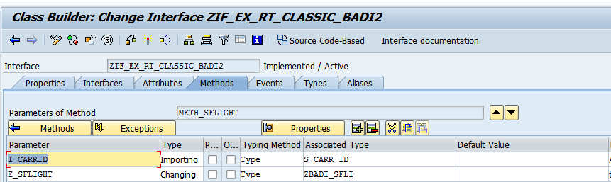

Table type :ZBADI_SFLI

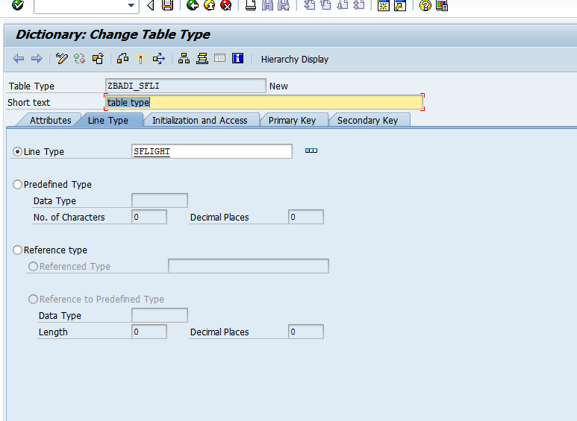

1. Save and activate the BADI

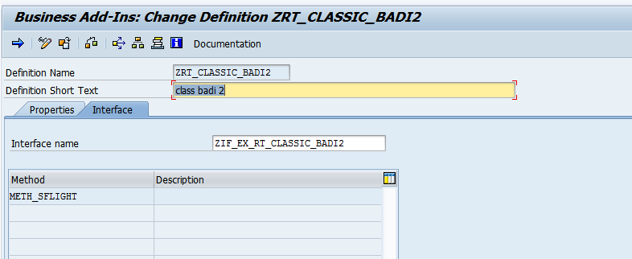

1. Go to tcode SE19. In the create implementation section, choose Classic BADI->give the name of the BADI created .

Click on create.

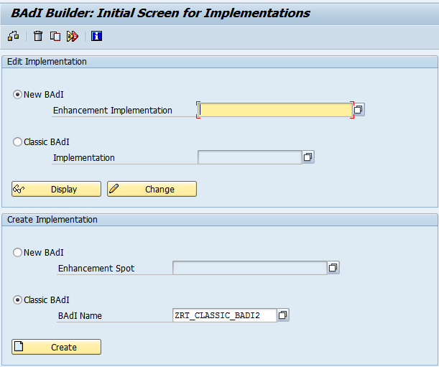

1. Give a suitable implementation name starting with Z/Y. Click on continue

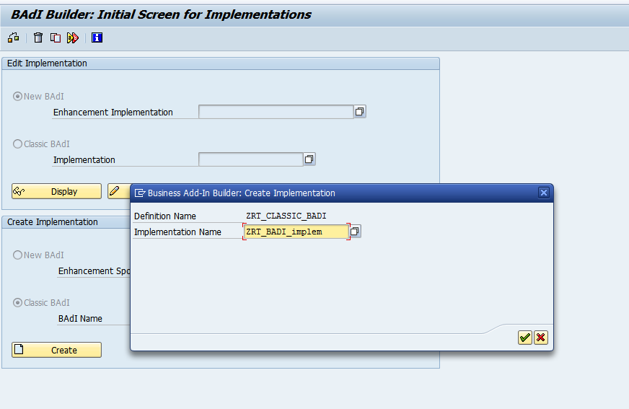

1. Give short description. **Click on the Plus symbol and add the value of CARRID Eg. AA.**

Click on the interface tab.

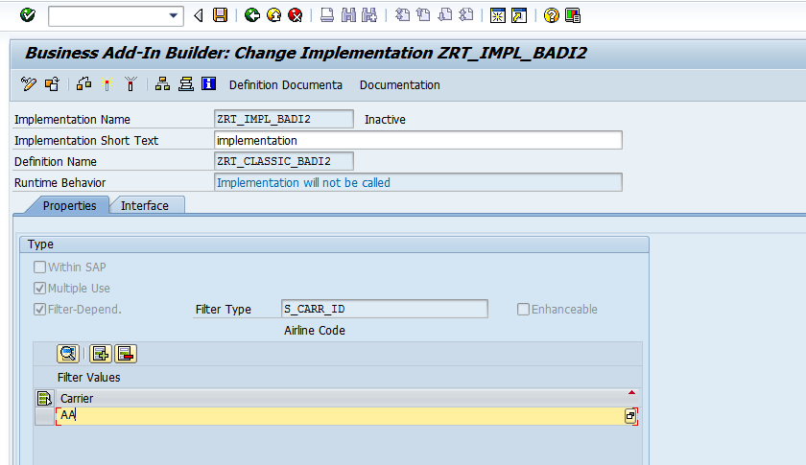

1. In the interface tab, double click on class and create it.

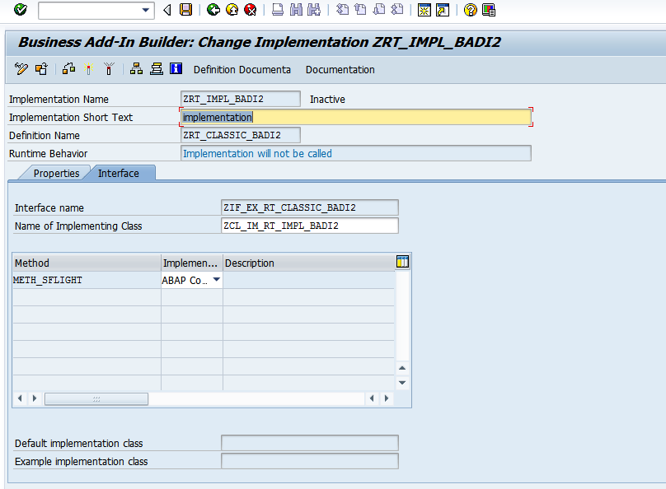

  select  carrid connid fldate seatsmax from sflight  
       into table ex_sflight  
        where  carrid = i_Carrid.

1. The class opens up. In the method METH_FLIGHT, add the below logic

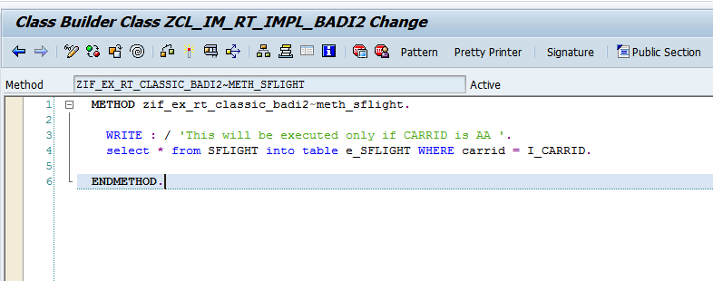

1. Save the class and go back.

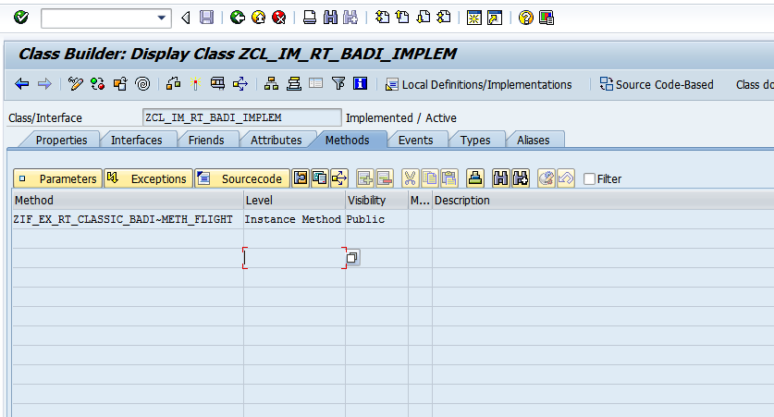

1. Save and activate the BADI Implementation. You will see a new importing parameter FLT_VAL gets populated

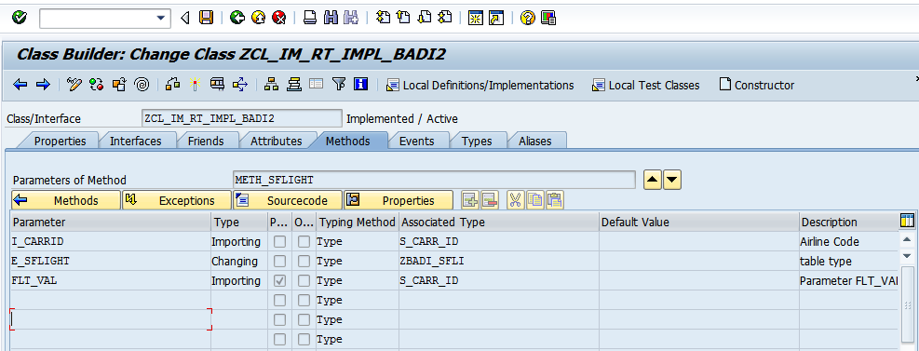

1. Create a Report in se38 and add the below logic

*\*&---------------------------------------------------------------------\**  
*\*& Report ZCLASSIC_BADI_PRG*  
*\*&---------------------------------------------------------------------\**  
*\*&*  
*\*&---------------------------------------------------------------------\**

REPORT zrt_classic_badi_prg.  
  
INCLUDE zrtassic_badi_prg_top.  
  
  
PARAMETERS p_carrid TYPE s_carr_id.  
  
  
START-OF-SELECTION.  
  
  DATA obj1 TYPE REF TO  zif_ex_rt_classic_badi2.*"Interface from se19*  
  
  
  CALL METHOD cl_exithandler=>get_instance  
    EXPORTING  
      exit_name = 'ZRT_CLASSIC_BADI2' *"Name of badi definition name*  
*\*     null_instance_accepted        = SEEX_FALSE*  
*\*  IMPORTING*  
*\*     act_imp_existing              =*  
    CHANGING  
      instance  = obj1  
*\*  EXCEPTIONS*  
*\*     no_reference                  = 1*  
*\*     no_interface_reference        = 2*  
*\*     no_exit_interface             = 3*  
*\*     class_not_implement_interface = 4*  
*\*     single_exit_multiply_active   = 5*  
*\*     cast_error                    = 6*  
*\*     exit_not_existing             = 7*  
*\*     data_incons_in_exit_managem   = 8*  
*\*     others    = 9*  
    .  
  IF sy-subrc <> 0.  
*\* Implement suitable error handling here*  
  ENDIF.  
  
  
  
  CALL METHOD obj1->meth_sflight  
    EXPORTING  
      i_carrid  = p_carrid  
**flt_val   = p_carrid  
    CHANGING  
      e_sflight = it_tab.**  
  
  
  LOOP AT it_tab INTO wa_tab.  
    WRITE : / wa_tab-carrid,  
              wa_tab-connid.  
  ENDLOOP.  
  
  IF it_tab IS INITIAL.  
    WRITE : / 'BADI was not executed'.  
  ENDIF.

10) The expected output is as follows when CARRID = AA

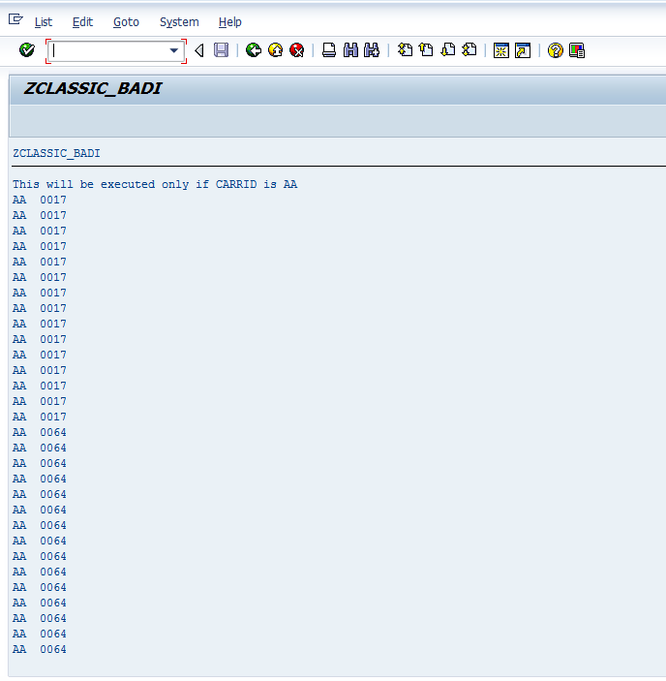

11) When CARRID is not equal to AA. The BADI is not executed.

